

MARCH 2022

**EMERGING FIELDS**

* **Education After School**
* **Medical Professions**
* **Technology**
* **Student’s Life**
* **Society And Individual**

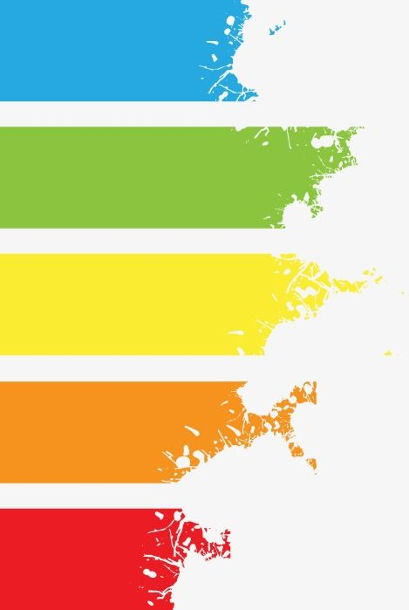

**CONTENTS**

4. SOCIETY AND INDIVIDUAL

3. PART TIME JOB

1. TECHNOLOGY

2. READING



**Editor’s Note:**

*For many of us, each New Year marks a chance for renewal, and 2022 is no exception. Every story in this issue speaks to challenge, opportunity, and the transformative power of hope. Each of these stories speaks to our faith in the future, and I’m excited to share them with you. Please keep your eyes on this magazine in the coming year for other signs of resilience and renewal. Because whatever changes 2022 may hold, one thing remains constant: our commitment to this planet we share.*

*Thanks.*



**STUDY TO SAVE LIVES**



Page 01

***Today’s students are interested in pursuing careers in emerging tech, an IBM and Morning Consult survey found. But they need more training and support to gain the necessary skills.***

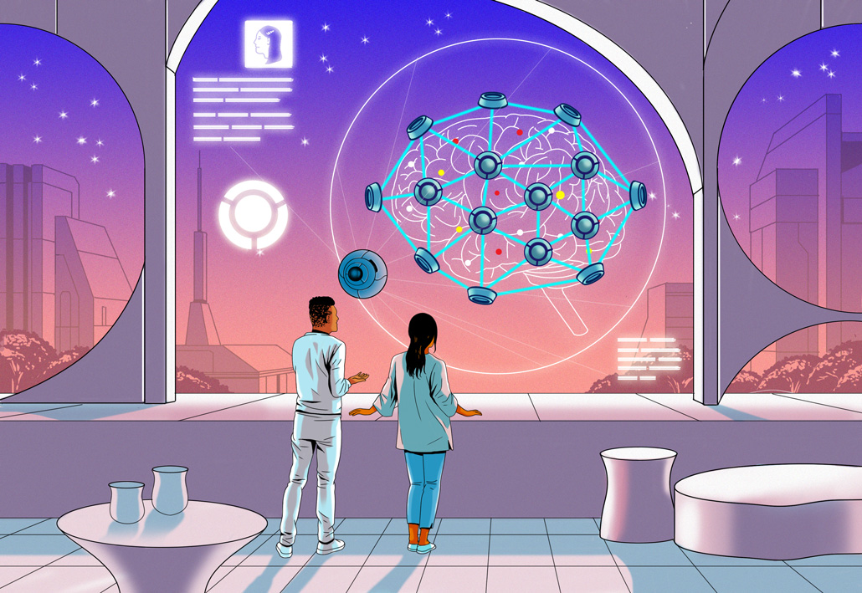

Page 02

***udents Report Interest in Emerging Tech***

**The survey found that 42 percent of students were interested in pursuing a technology career. More than half said it was because most jobs will**

**require the use of technology.**

**Others cited their personal interest (50 percent) and the fact that tech jobs pay well (46 percent).Students were particularly interested in learning more about AI (50 percent), followed by cybersecurity (47 percent) and cloud technology (42 percent). Yet less than a third felt equipped to use these technologies in their life**

**or career, according to the report. Meanwhile, students who said they weren’t interested in emerging tech cited numerous reasons why: 42 percent said it was because they didn’t find any of the areas exciting or engaging, while others noted it was because they didn’t understand them (24 percent) or have time to learn more (16 percent).**

**or career, according to the report. Meanwhile, students who said they weren’t interested in emerging tech cited numerous reasons why: 42 percent said it was because they didn’t find any of the areas exciting or engaging, while others noted it was because they didn’t understand them (24 percent) or have time to learn more (16 percent).**

**How to Teach Gen Emerging Tech Skills**

**To prepare Gen Z for the future of work, schools need to recognize and support student interest in emerging technology, says Grace Suh, vice president of IBM Education.**

**“We know that almost all jobs will change in the future due to AI and automation. Students will need a variety of 21st century skills to succeed,” she says. “Looking at the changes in education and work, offering specific types of learning experiences for all students is most beneficial.”**

Page 03



**READING FOR ME, READING FOR OTHERSM**

*I don’t quite remember when I learned how to read, or even who taught me, but I do remember*how *I learned-* **Michael Deschences**

Page 04

***Michael Deschenes is 17 years old and lives in Pasadena, California. He enjoys writing, especially for his school’s newspaper, The Paw Print, for which he is the opinion editor. He also loves reading, camping, and playing badminton and basketball.***

I’d sit down next to a parent, or a sibling, or a grandparent, or a teacher, and watch them read, absorbing the mannerisms that seemed to define that very act. When I was a toddler, I would scan lines of text and flip pages with a complete lack of comprehension, simply hoping to emulate the readers in my life. After looking on for some years, I began to try out letters, words, phrases — to test the literary waters.



Page 05

My vocabulary and confidence slowly grew as I moved from The Cat in the Hat to Diary of a Wimpy Kid to Harry Potter. Just as I had watched the readers around me when I was younger, my teachers now watched and guided me, correcting me when I misread or misunderstood. By second or third grade, I had become the reader I am today, voracious yet indecisive, often juggling more books than convenient.

I came to realize, at some point in elementary or middle school, that **many don’t have the same experience of learning to read as I did, for reasons socioeconomic, familial, or even geographic in nature.**The unfortunate absence of reading in some of my peers’ early lives seemed an even more disappointing reflection of more general problems within our education system. On a more personal level, I tried to imagine my life without the role models that sprung from the books of my youth: Will of the Ranger’s Apprentice series, Hermione, Percy Jackson, and so on. I couldn’t. Education, which should be the great equalizer, seemed to have fallen short for some students. I decided action was necessary, but the proper avenue for that action was unclear.

When I stumbled upon Reading Partners right before my freshman year of high school, I knew I had found the best option for me. Reading Partners, a national literacy organization, operates mostly in underfunded elementary schools in cities across the United States, coordinating individualized tutoring sessions for struggling students in kindergarten through third grade. Tutors for Reading Partners are provided with abundant resources and guided through each session by an intuitive lesson plan, which allows the

them to focus on building positive relationships with their students while directing educational growth. I began tutoring for Reading Partners that year and have continued to do so nearly every week since. Each individual Reading Partners tutoring session mirrors, at least in a general sense, the experience I had while learning to the reading. To begin, the student and tutor pick out a book for the tutor to read. Known as the “read aloud” portion, this part of the lesson gives both the tutor an opportunity to demonstrate what a proficient reader looks like and the student a chance to share that experience of reading, and with a book of their choice at that. **In these minutes, I am miraculously now the model for another budding reader, completing an educational cycle.**Not only is the reciprocal demonstration of the reading, in my mind, the logical extension of everyone’s early years of sitting by others, but teaching another student also offers me the chance to understand both just how similar my student and I are and the role others have played in my education. Where the older people in my life gently guided my reading and oration, I now can do the same for another student. It is important to remember that the latter half of that sequence is directly predicated on the first. My reading ability — just as is the true for nearly all other abilities of mine — is the product of my interactions with many the formal and the informal instructors. The next part of the tutoring session on

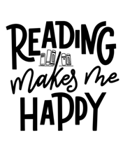The next part of the tutoring session focuses on the direct instruction and then implementation of reading fundamentals or strategies. After reading to my student for 10 minutes, I might work through vowel pairs or sentence structure or inference patterns, providing methods for them to be more comfortable in moving through a more advanced text than ones with which they are already familiar.

The hour ends with the student reading a book that corresponds to their reading level. For some students, this part of the session is the best, a moment for them to show their confidence and advance their learning; for others, it can be terrifying, a moment during which they must face an activity with which they have struggled in the past. Through it all, every student in Reading Partners continues to grow. Particularly with students I have worked with over months or even the entire school year, **witnessing this reading process is an experience incomparable with any other.**

In my three years with Reading Partners, I have not guaranteed the educational success of all of its students, revolutionized the act of teaching, or even ensured the reading success of any individual student. But I have been able to offer an improved reading ability to a few, which is gradual change but change nonetheless. I have come to understand the measured instruction and patience that must accompany teaching. I have learned about the intricacies of the mind of the beginning reader. Most importantly, I have seen the blossoming of countless young students, students who will undoubtedly continue to learn, become more confident readers, and ultimately sit down with someone else and show them the great wonder of reading.

Page 06



BEING

A

PART

TIME

STUDENT

Page 07

**PROS AND CONS**

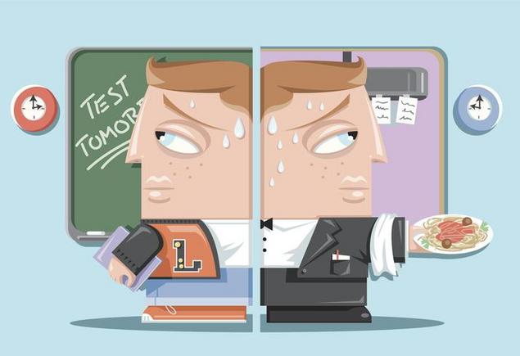

**Being a part-time student gives you a flexible schedule:**When you’re a part-time student, you have more time flexibility as you slow down the pace of your learning. You take fewer classes per semester so you can focus on other things in life. The majority of full-time workers choose to become part-time students as it allows them to progress through college while enjoying the financial benefits of employment. Also, the variety of online part-time study programs has made advanced education more accessible to a wider number of people—right from the comfort of their homes.

**You can find a fresh new direction:** College is a [precious period in life](https://psychcentral.com/lib/growth-and-change-through-the-college-years/) when people get to explore their interests and find out new parts of their identities. It consists of many steps that lead towards finding a true calling or discovering something you care deeply about. By becoming a part-time student, you can experience all of this while ensuring you’re not overwhelmed by the transition to a new environment. It can be a less stressful way to step into an unknown life phase.

“THE BEST WAY TO PREDICT YOUR FUTURE IS TO CREATE IT.”

**Lower tuition costs:** When you’re a part-time student, you naturally have lower fees as you take fewer courses than full-time students. This creates less financial burden as you spread out the costs throughout a longer time frame, whereas full-time students have to pay a larger amount of money at one time and might even bury themselves in student loan debt.

Page 08

**The overall duration of studies increases:** It can take twice as much time to finish a particular study program as a part-time student – it all depends on how many credits you decide to register for. A potential downside is experiencing a lack of motivation to continue pursuing a degree which can prolong studies even further. This can be a huge setback if you wish to use your degree to move up the career ladder and perhaps obtain your dream job

**Education is the most powerful weapon you can use to change the world.**

**You’ll need a good support system:** People often feel at ease when they focus on one particular area of life and invest their time and energy into it. As a part-time student, you’ll likely be juggling lots of tasks and priorities. Most of the professors who teach part-time students understand their intense life tempo but it’s also advisable to find a good support system at home and have your family and friends close by.

**Fewer Scholarship opportunities:** [Scholarships](https://www.collegeraptor.com/scholarship/search/) are typically intended for those with low financial need. If you are a part-time student who happens to be working full-time, you may not have as many chances of [getting financial aid](https://www.collegeraptor.com/student-loan/finder/). In addition to this, on-campus housing is typically unavailable to part-time students and they don’t get to enjoy many of the privileges of campus life.In any case, being a part-time student is not easy. It takes a lot of time-management skills, commitment, and determination. Although the dynamics of part-time study programs are a bit different and possibly less overwhelming, every course has deadlines you have to meet.

Page 09

**SOCIETY AND INDIVIDUAL**

**I feel like I am being watched  
Every step I take, they are judging my choices  
They are breathing down my neck  
They are scrutinizing my every move  
Paranoia escalates  
I don’t know why I feel like I am being watched**

**Then I realize I just posted on my Instagram page**

**It feels like when I bring Society into my existence it never turns out right  
They always say there is something wrong with my picture  
They say the clothes I love are disgusting  
The way I wear my hair is disgusting**

**The picture I see is perfect, but to everyone else  
It is just another piece of trash that has been thrown on to the sidewalk never to be seen again**

**Sometimes it feels like you can never please the terrible world  
Called Instagram or Snapchat  
Or anything else that has people posting about how great their lives are  
As others respond with a like or hateful comment.**

**When they say,  
This is my Facebook  
This is my Instagram  
This is my story  
They really mean  
This is my life so that society can either hate or love**

**I feel pain running through me  
I conceal my hate, and I fix it  
With a little thing called a filter because  
My face, my life is not good enough  
For the society that reigns above**

**My life revolves around what I look like and what I do for society  
It is a dance between me and society  
You make all the right steps and they love you  
But screw up once and they will think you are nothing**

**I feel like I am not myself when I post something that doesn’t look like me at all  
Because the problem is . . . is it me or what society wants me to be?**

Page 10



**GROUP MEMBERS:**

1. **LAIBA SOHAIL (2021-BSE-016)**
2. **NEHA AMJAD (2021-BSE-024)**
3. **AYESHA TARIQ SATTI (2021-BSE-005)**
4. **TANZEELA ASGHAR (2021-BSE-032)**